Set up and Configure Spring Boot Applications that Rely on Smart Card Single Sign on Using SAML 2.0 Provided by Keycloak Server

Purpose: We want to set up Spring Boot applications that use authentication based on SAML (Security Assertion Markup Language), which is an open, XML-based standard used to securely exchange authentication and authorization data between an Identity Provider (IdP) and a Service Provider (SP). Keycloak server is one of Identity Providers. To access the Spring applications, users need to use smart card certificates to sign on. This document provides steps about how to generate sets of required certificates, set up Spring Boot applications, and configure Keycloak server to achieve this goal.

Part I: Generate Certificates for Keycloak
We need to create sets of certificates to secure our Keycloak server and Spring applications.

1. Create Public/Private Keys for Keycloak to Run on SSL (https)
Create self-signed certificate for Keycloak to run on SSL (https), see openssl-generate-keycloak-keys.bat.
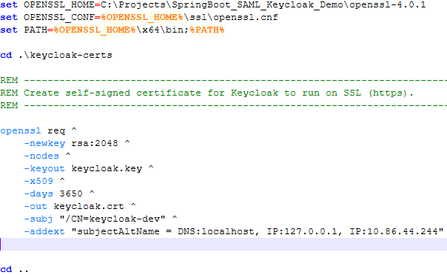
openssl req ^
-newkey rsa:2048 ^
-nodes ^
-keyout keycloak.key ^
-x509 ^
-days 3650 ^
-out keycloak.crt ^
-subj "/CN=keycloak-dev" ^
-addext "subjectAltName = DNS:localhost, IP:127.0.0.1, IP:10.86.44.244"
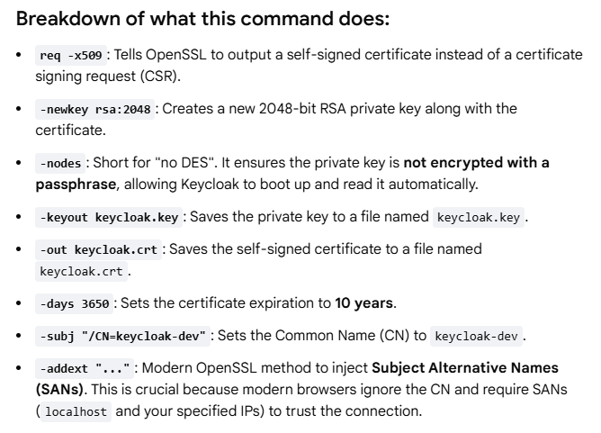
2. Create CA Root Trust Store to Enable Smart Card X.509 Authentication
For enabling X.509 authentication, Keycloak needs a trust store containing the CA that issued your smart-card certificate to validate smart-card client certificates. Therefore, we need to download the root CA certificate and install it in a trust store or create a trust store file.
Export CA root certificate as a .cer file, for example BAE_Root.cer:
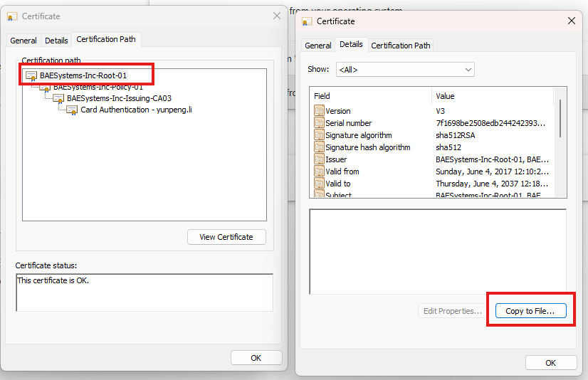

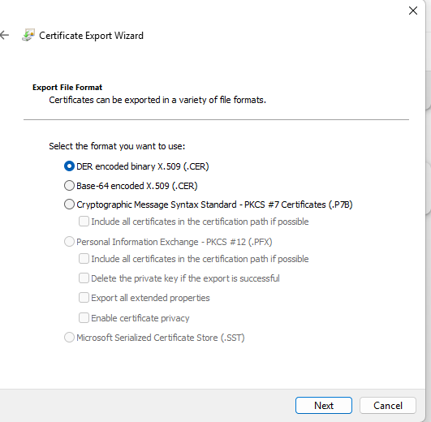

Then use keytool to install CA root certificate in a trust store or create a trust store file (see keytool-generate-ca-truststore.bat):
In this case, a trust store file, root_ca_truststore.p12, is created from BAE_Root.cer, the CA root of the smart card.

3. Run Keycloak on SSL
Start Keycloak by running start-keycloak-ssl.bat. Important command arguments in start-keycloak-ssl.bat:
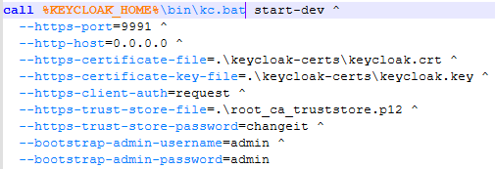

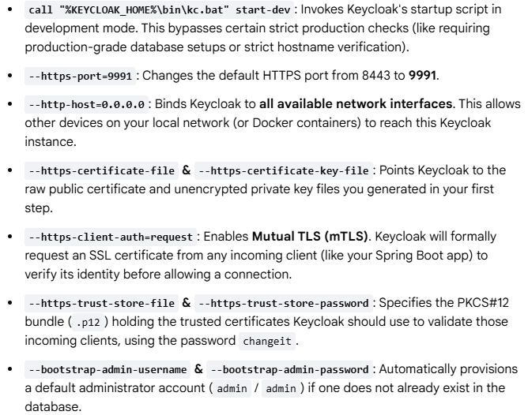
Part II: Set up Spring Boot Projects

1. Create Public/Private Keys to enable Spring application to run on SSL
Create self-signed certificates (see openssl-generate-spring-keys.bat):
openssl req ^
-newkey rsa:2048 ^
-nodes ^
-keyout springboot-server.key ^
-x509 ^
-days 3650 ^
-out springboot-server.crt ^
-subj "/CN=spring-localhost" ^
-addext "subjectAltName = DNS:localhost, IP:127.0.0.1, IP:10.86.44.244"

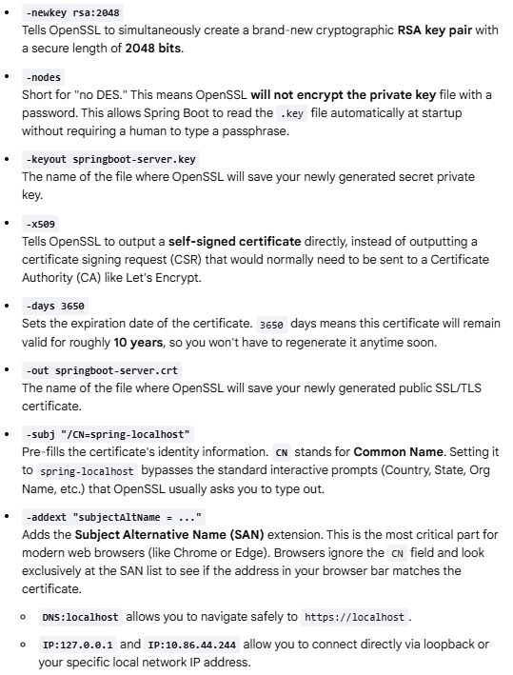

Bundle certificates (see openssl-generate-spring-keys.bat):
openssl pkcs12 ^
-export ^
-in springboot-server.crt ^
-inkey springboot-server.key ^
-out springboot-server.p12 ^
-name springboot ^
-passout pass:springbootpass
This command takes the SSL certificate and private key you generated earlier and bundles them together into a single, encrypted file called a PKCS#12 archive (usually ending in .p12 or .pfx). Spring Boot cannot natively read raw .crt and .key files easily, so it requires this .p12 keystore format to enable HTTPS. The springboot-server.p12 should be copied under the src/main/resources of your Spring Boot application, so that it can communicate with Keycloak server on HTTPS.
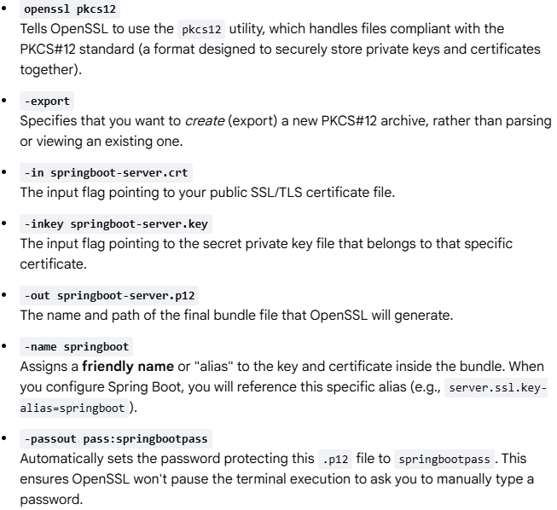
PKCS#12 (Public-Key Cryptography Standards #12) is an industry-standard archive file format used to bundle a private key alongside its matching X.509 public key certificate into a single, password-protected binary file. springboot-server.crt is the public key, and springboot-server.key is the private key.

2. Create Public/Private Keys for SAML Signature Signing
Create self-signed certificates (see openssl-generate-spring-keys.bat):
openssl req ^
-newkey rsa:2048 ^
-nodes ^
-keyout springboot-signing.key ^
-x509 ^
-days 3650 ^
-out springboot-signing.crt ^
-subj "/CN=CN=SpringBoot_SAML_App" ^

Convert the previously created private key file from its legacy format into the modern, standardized PKCS#8 format:
openssl pkcs8 ^
-topk8 -inform PEM ^
-outform PEM -nocrypt ^
-in springboot-signing.key ^
-out springboot-signing-pkcs8.key
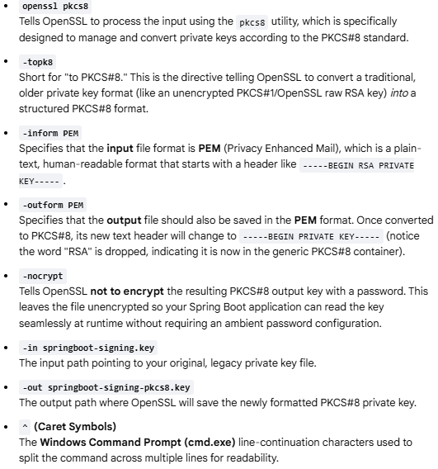

3. Configure Spring Security
Include Spring security and SAML2 packages and the repository that hosts the libraries in pom.xml.
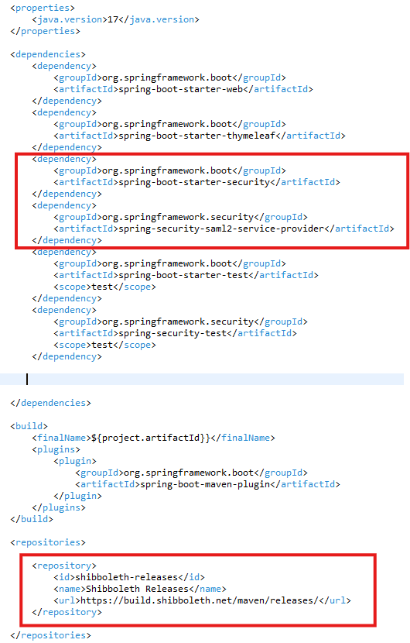

Copy springboot-server.p12 file generated in previous step under src/main/resources/certs/
This is the bundled certificate that enables your Spring application to run on SSL (https).
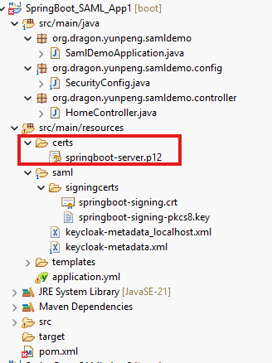

Copy springboot-signing.crt and springboot-signing-pkcs8.key generated in previous steps under src/main/resources/saml/signingcerts/
They are the certificates for your Spring application to sign authentication request during communication with Keycloak server.
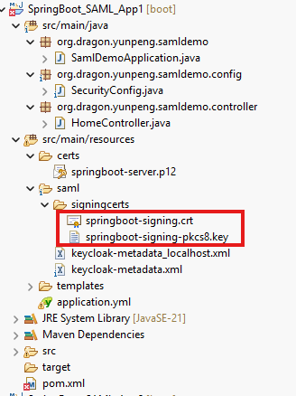

Create a file named keycloak-metadata.xml and copy the content from SAML 2.0 Identity Provider Metadata in Realm settings of KeyCloak described in "Create a Security Realm" section in Part III of this document. This xml contains metadata of Keycloak SAML authentication. You can specify the metadata URL pointing to Keycloak metadata in your application.yml or SecurityConfig.java. But if Keycloak server is not up and running, your Spring application will not successfully start, so for demonstration purposes, storing an XML file in your Spring application’s local directory can prevent such issues.
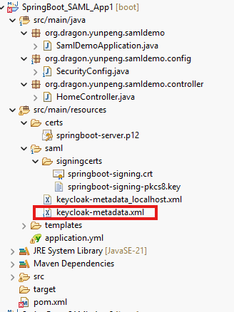

Add configuration in SecurityConfig.java:
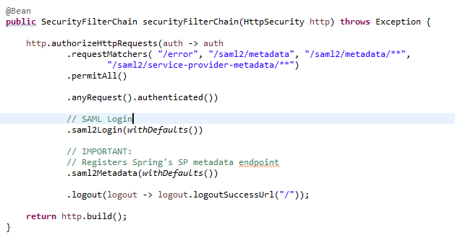
Add configuration in application.yml:
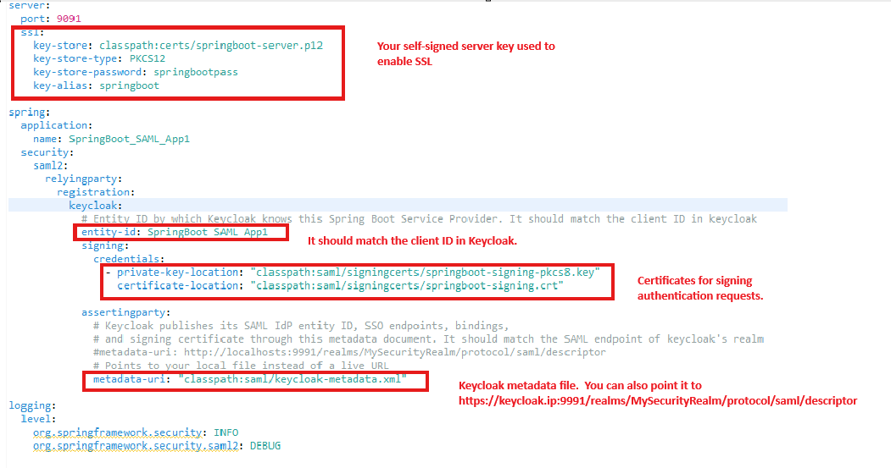
The Spring Security configuration is relatively simple.
See HomeController.java about how to retrieve authentication and principal objects after successful SAML authentication:

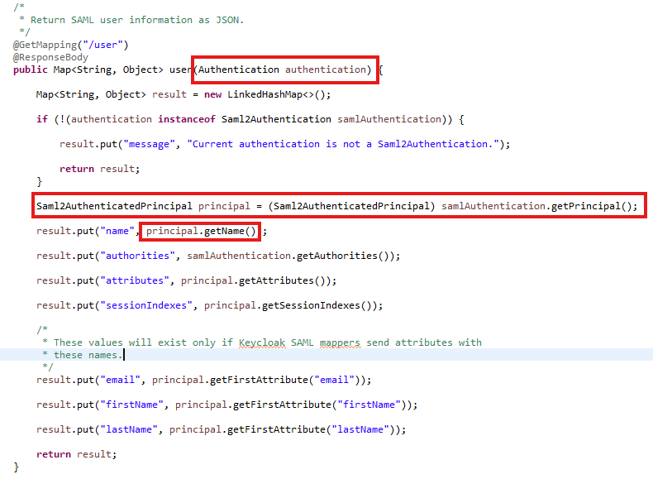

Part III: Configure Keycloak to Enable SAML Single Sign On
We want to configure single sign on to ask user to use X.509 (smart card certificate) to do authentication first. If user cancel or ignores the X.509 authentication, the username/password authentication form should be the fall back. If single sign on authentication has been done previously, the authentication flow should go through cookies first. Therefore, an authentication flow needs to be created under the security realm. We assume the CN value of the user’s smart card certificate will be used to test the match of the username of a user defined in the Keycloak security realm during the authentication.

Suppose Keycloak server starts at localhost:9991. Login as admin/admin
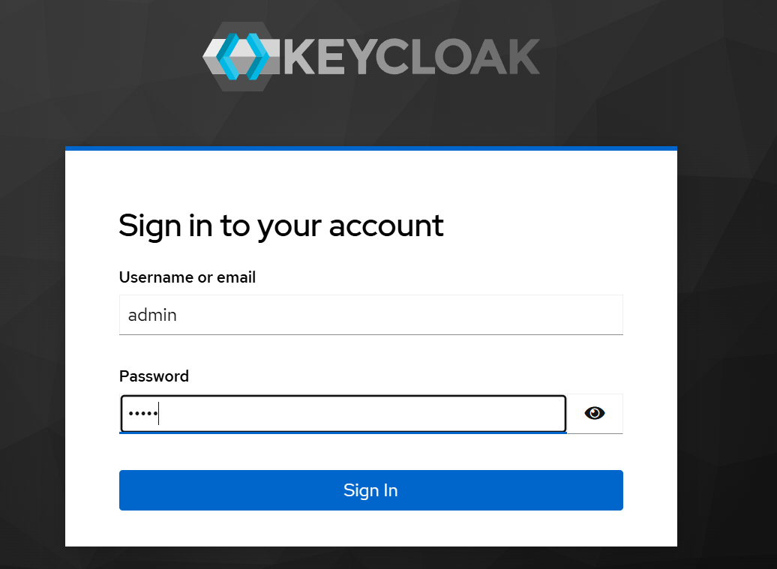

1. Create a Security Realm
In Keycloak, a realm is the highest-level logical boundary used to create an isolated identity and security domain. Think of it as an independent “container” or tenant inside a single Keycloak installation that behaves like its own separate identity.

Click Manage realms and then click Create realm:
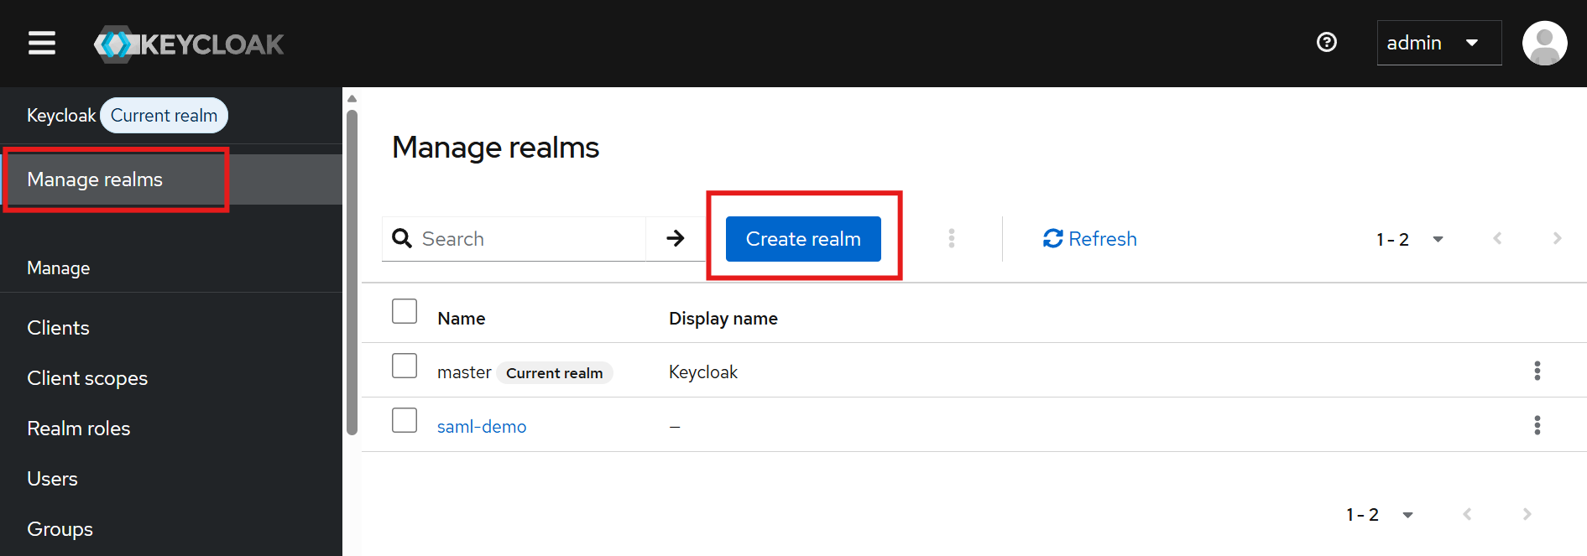
Provide a realm name then click Create:
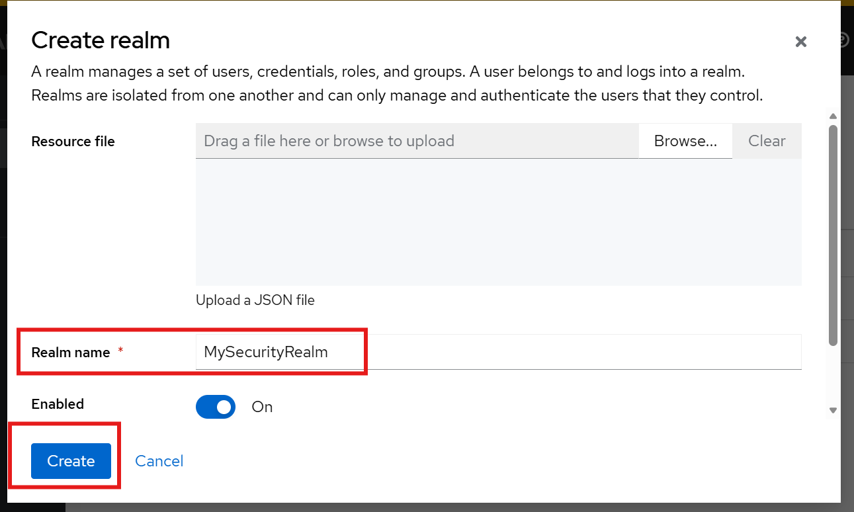

Explore realm SAML metadata by clicking Realm settings, then click SAML 2.0 Identity Provider Metadata. Such metadata contains important information for applications (SP) to communicate with Keycloak during authentication. It should be included in the security configuration of your Spring applications. The URL of this metadata or a copy of metadata XML file should be included in the security configuration of the Spring applications.
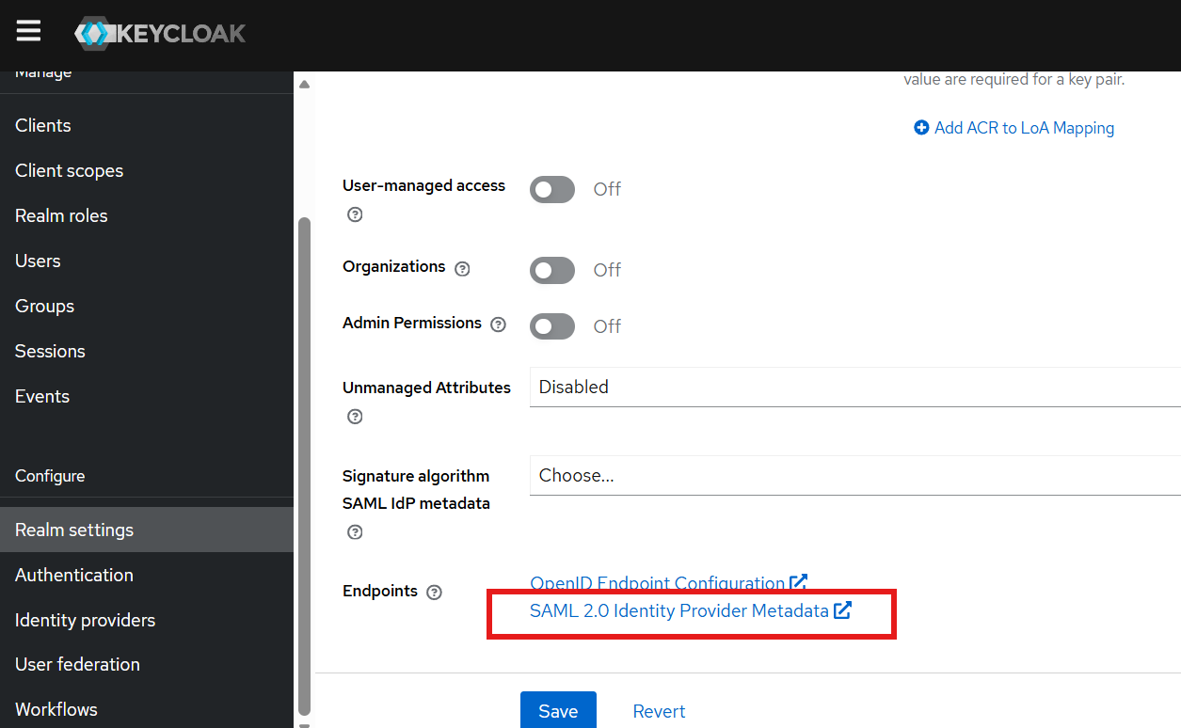

The IDP metadata should look like:
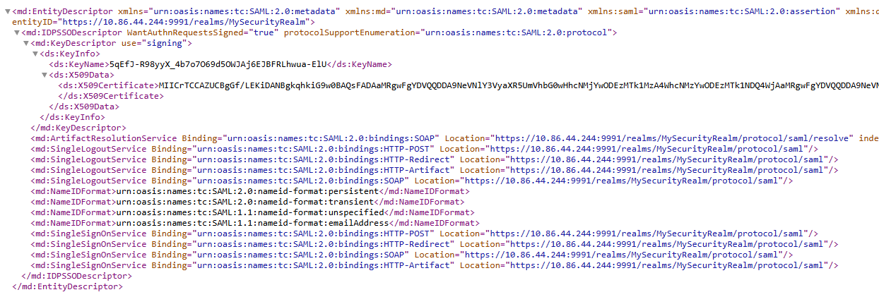

2. Create Clients in the Security Realm
Clients are the applications, websites, or microservices that rely on that specific realm for authentication. They are considered as the correspondents or representatives of your Spring applications.
Make sure the current realm is your newly created realm. A client in Keycloak is describing a Service Provider, which should match the Spring Boot application.

Create the 1st Client:
Click Clients then click Create client:
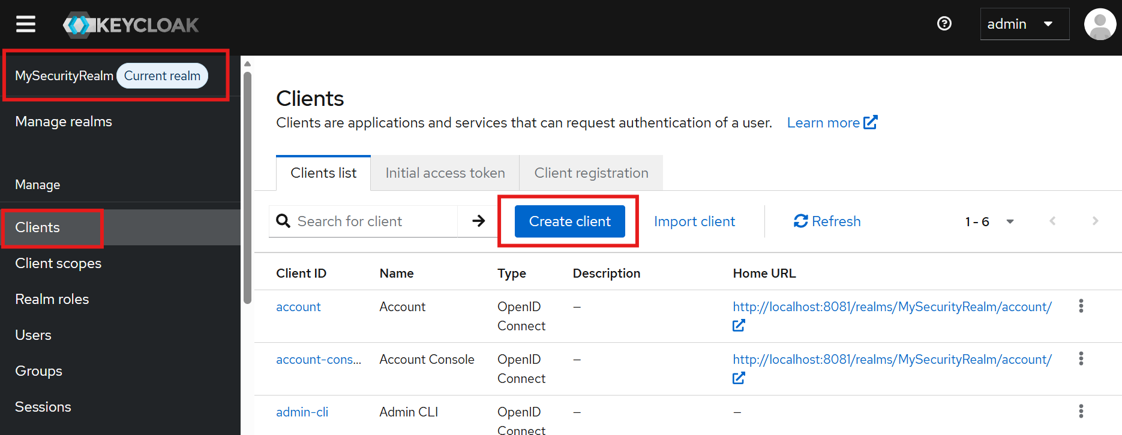

Choose Client type: SAML, enter Client ID: SpringBoot_SAML_App1, then click Next:
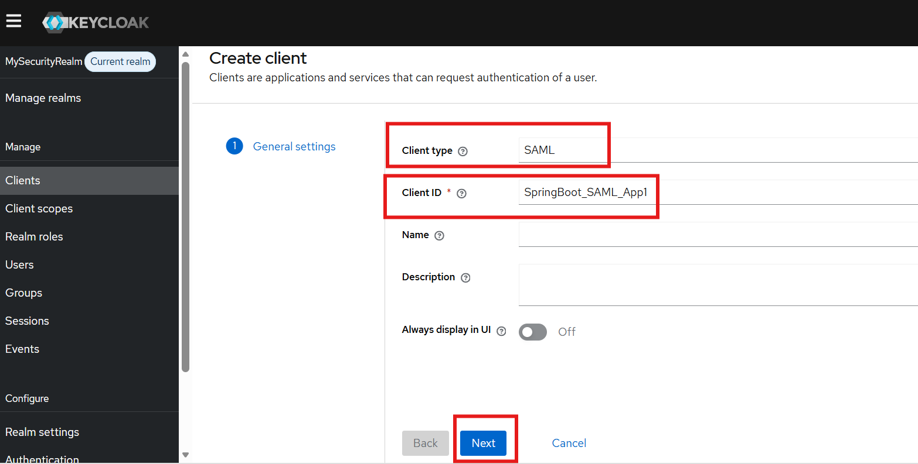

Enter the URLs about the Spring Boot application and click Save. The Master SAML Processing URL will be used for every binding to both the SP's Assertion Consumer and Single Logout Services. “/login/saml2/sso/keycloak” is a default URL that tells Spring Security to handle SAML Assertion Consumption.

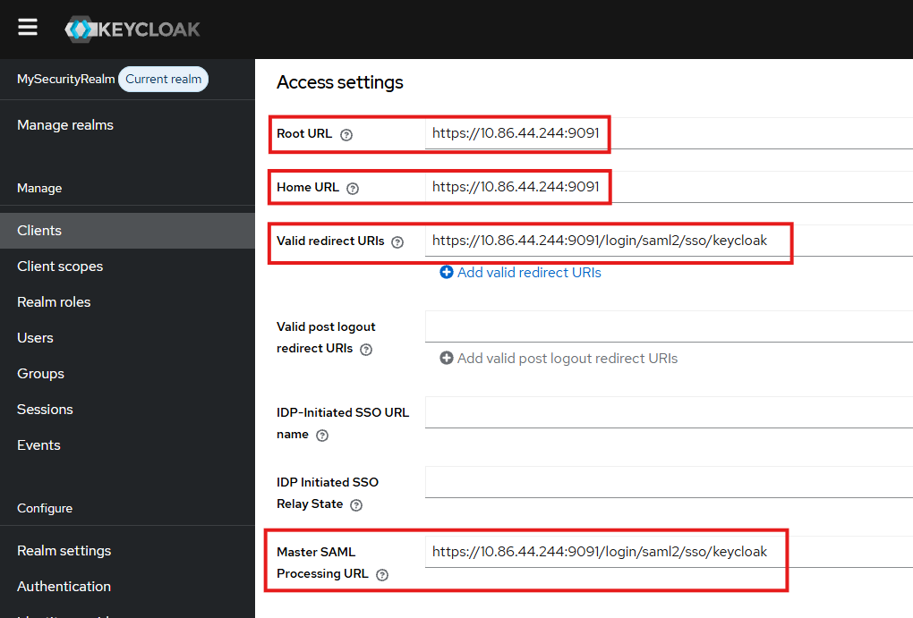

Temporally disable Client signature required, but we will provide the URL of the metadata of the Spring application to deal with signing. The benefit is Keycloak will automatically know how the authentication request is signed by the Spring application by dynamically reading the SAML2 metadata provided by the Spring application.
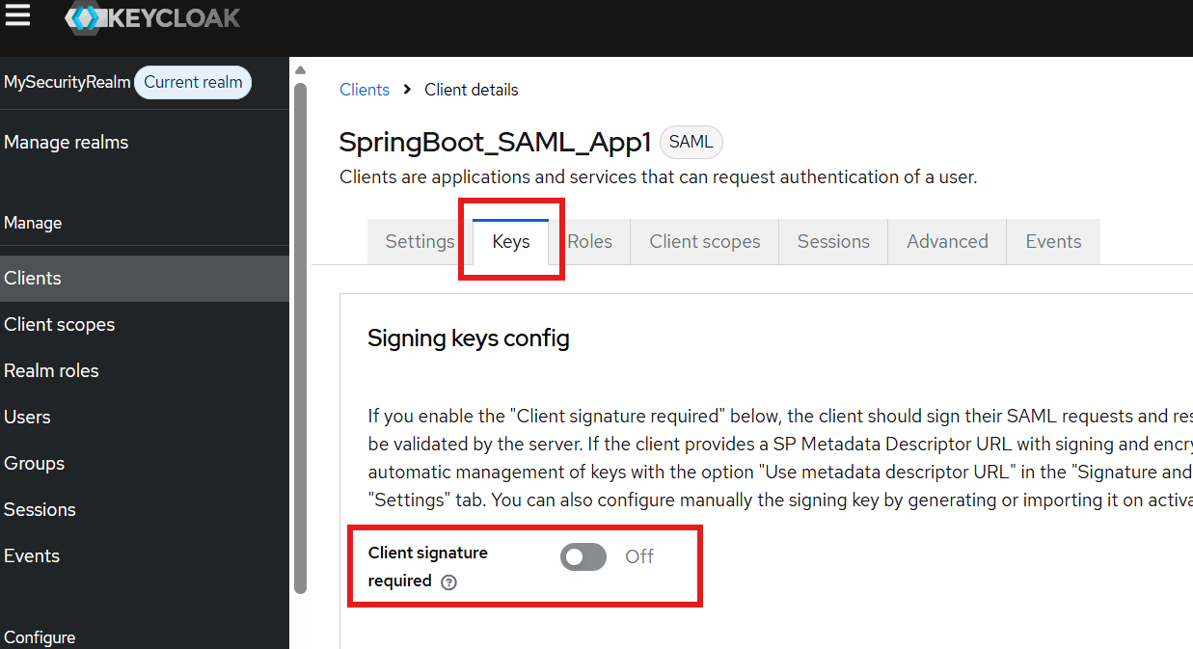

Provide the URL of the SAML metadata endpoint of your Spring application. It should look like https://applicationIp:9091/saml2/metadata/keycloak
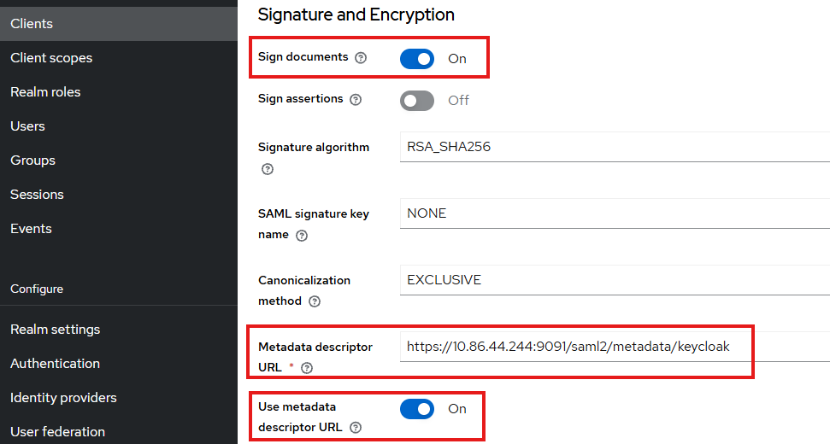

Create a 2nd Client:
Click Clients then click Create client:

Choose Client type: SAML, enter Client ID: SpringBoot_SAML_App2, then click Next:
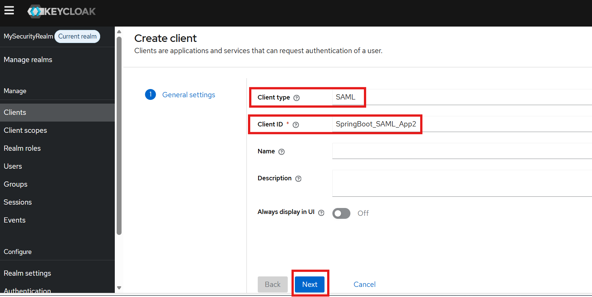

Enter the URLs about the Spring Boot application and click Save. The Master SAML Processing URL will be used for every binding to both the SP's Assertion Consumer and Single Logout Services. “/login/saml2/sso/keycloak” is a default URL that tells Spring Security to handle SAML Assertion Consumption.

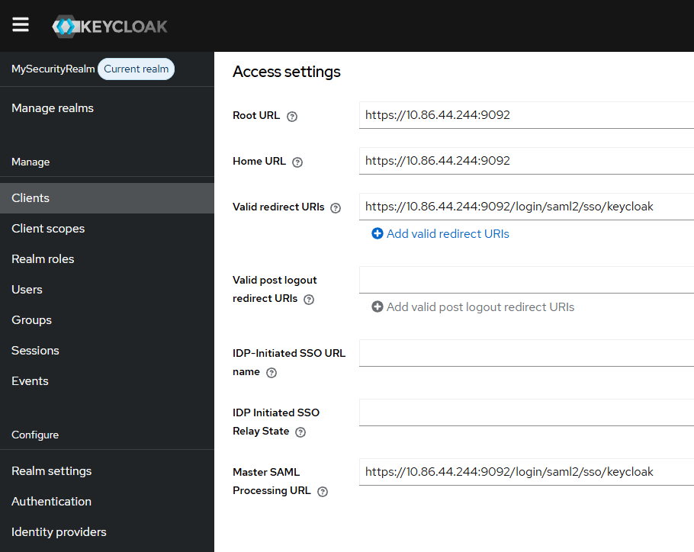

Temporally disable Client signature required, but we will provide the URL of the metadata of the Spring application to deal with signing. The benefit is Keycloak will automatically know how the authentication request is signed by the Spring application by dynamically reading the SAML2 metadata provided by the Spring application.
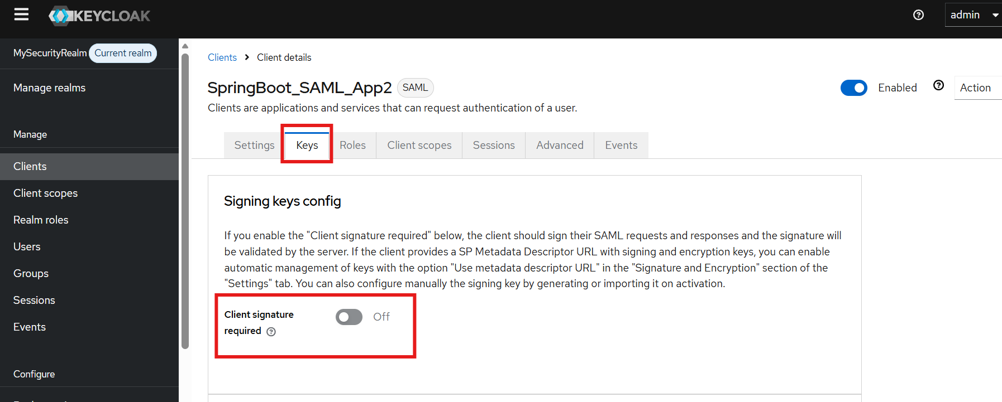

Provide the URL of the SAML metadata endpoint of your Spring application. It should look like https://applicationIp:9092/saml2/metadata/keycloak
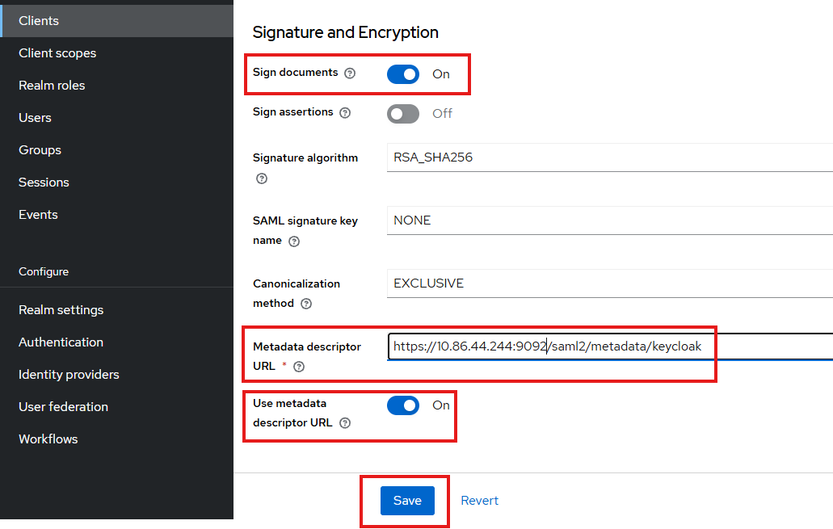

3. Create a User in the Security Realm
A user in a Security Realm can potentially single sign on all Service Providers (Spring applications) configured under the Security Realm.
Click Users link and then click Create new user:
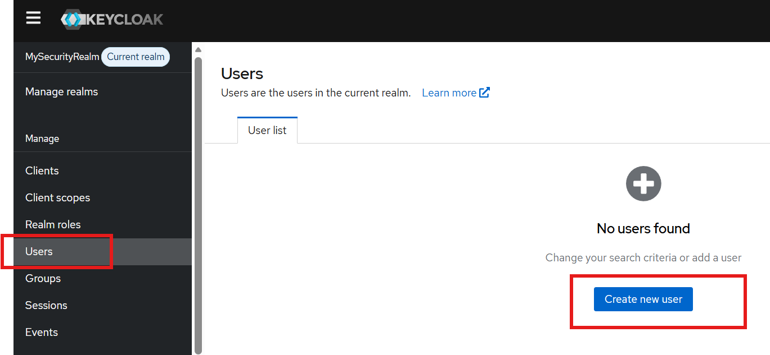

Enter Username (should match your CN of your smart card) and other information then click Create:
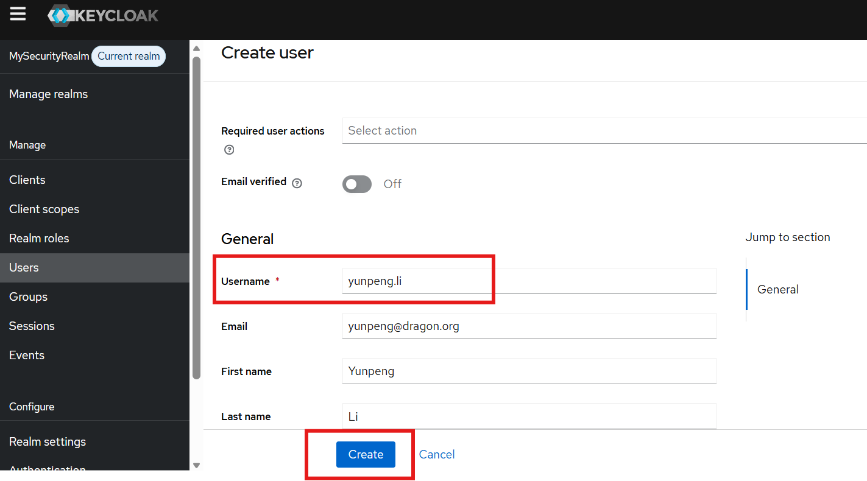
Click the Credential tab, then in the popup form, enter the password and choose the Temporary selection as Off (It won’t ask user to change password when first login), then click Save:
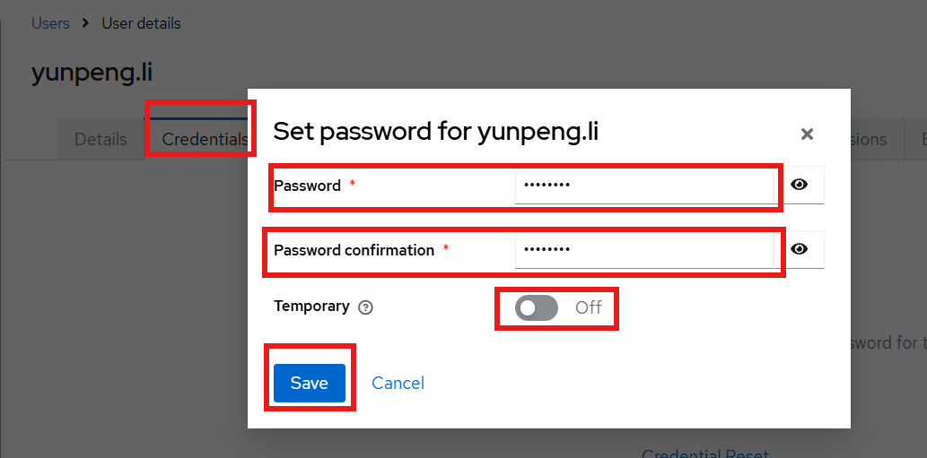

Part IV: Configure X.509 User Certificate (Smart Card) Authentication Flow in Keycloak
Authentication Flow is a logical container for all the screens, checks, validations, and challenges a user or service must complete to successfully verify their identity.Instead of hardcoding a standard username-and-password login screen, Keycloak uses an extensible, visual step-by-step pipeline. This allows you to construct sophisticated logic, such as conditionally prompting a user for a password, requiring a Multi-Factor Authentication (MFA) token, or routing them through a social identity broker.

Login as the Keycloak administrator. Switch to the security realm that we want to configure the authentication flow. Under the security realm (MySecurityRealm), click Authentication then click Create flow button:
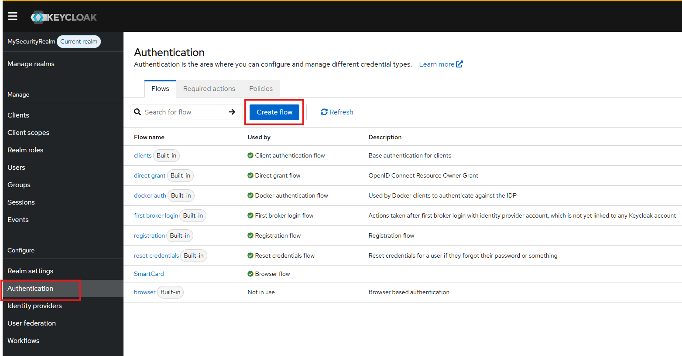

Provide the name (MySmartCardX509) of the authentication flow and click Create:

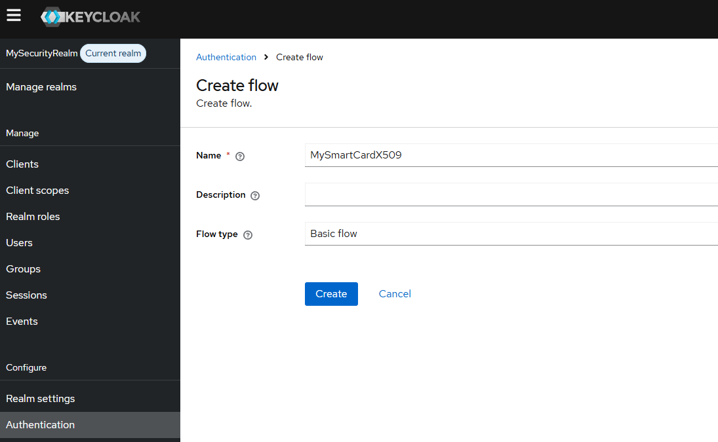

Then click Add execution to add an execution step in this flow:
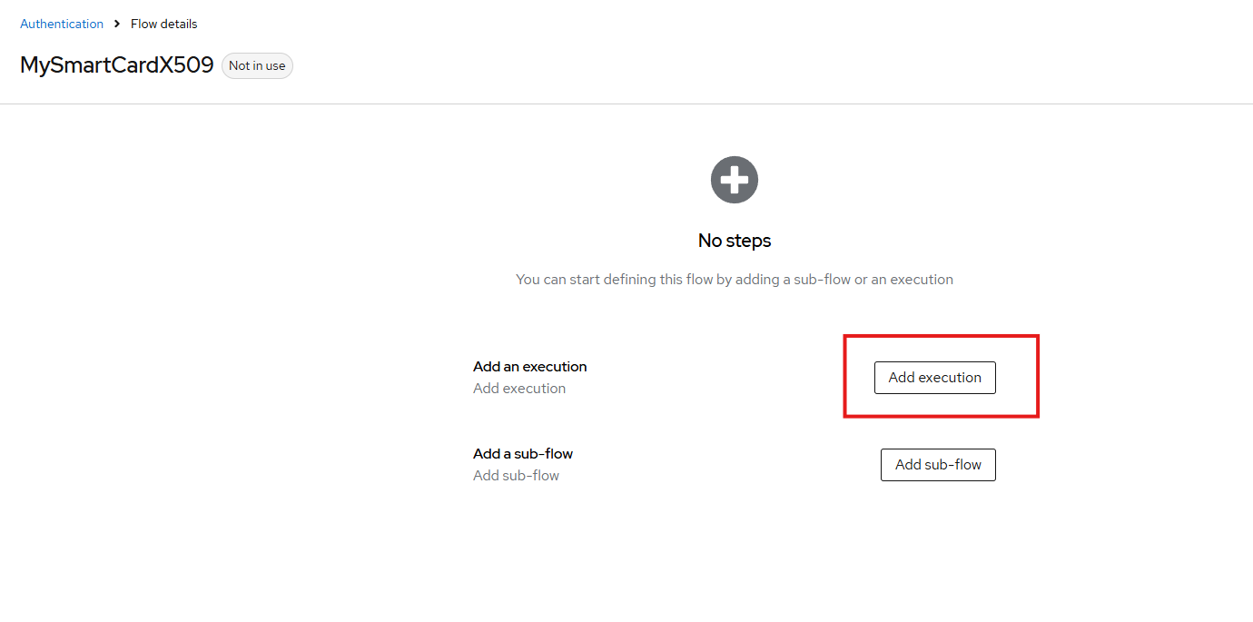

Find and choose Cookie then click Add:
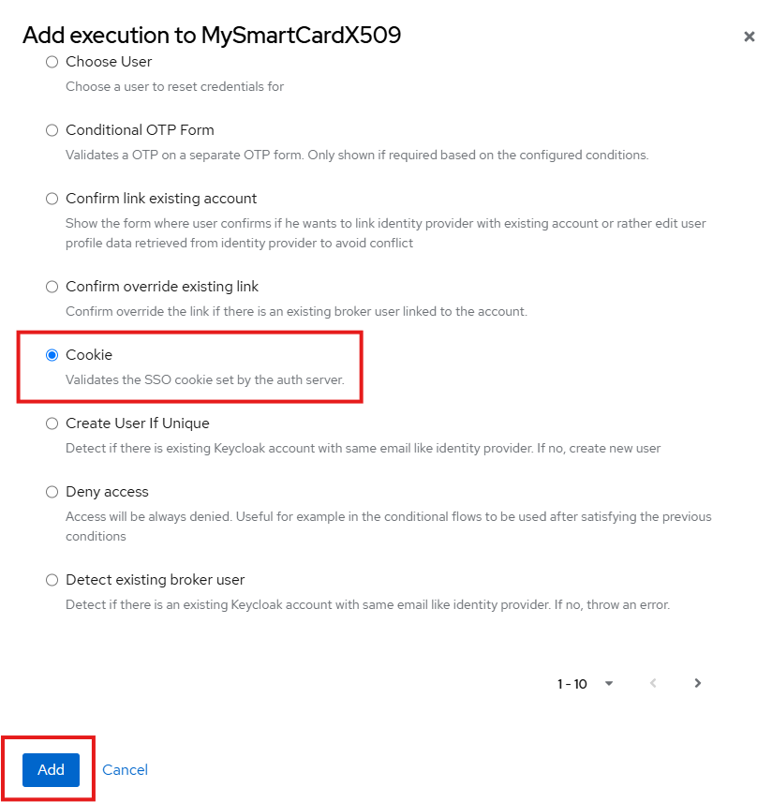

Choose Alternative under Requirement, then click Add execution to add another execution step:
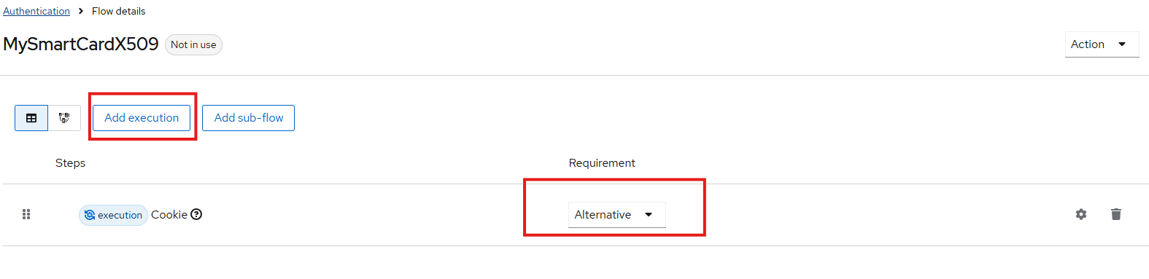

Find and choose X509/Validate Username Form, then click Add:
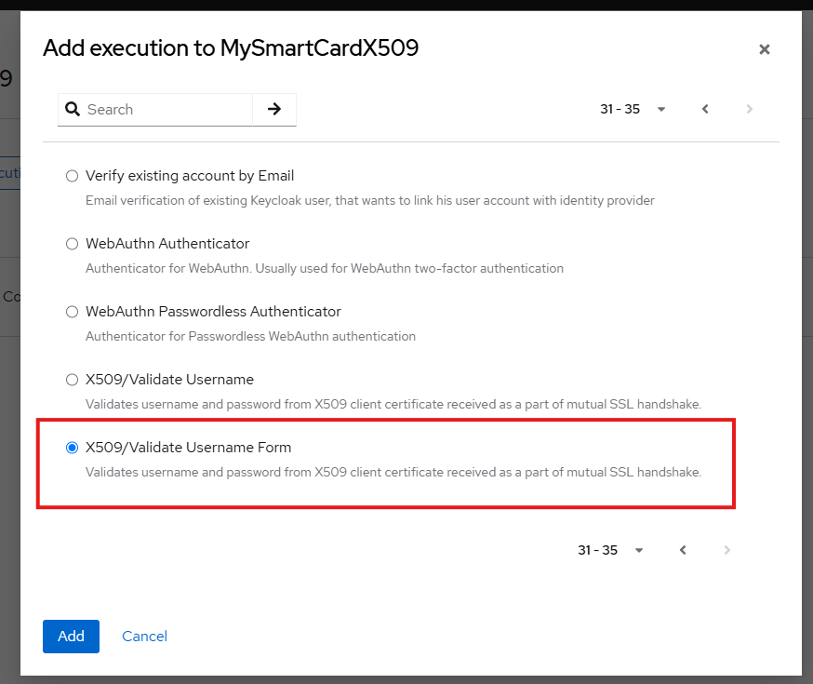

Choose Alternative under Requirement column in X509/Validate Username Form row, then click Add sub-flow to add a sub-flow:

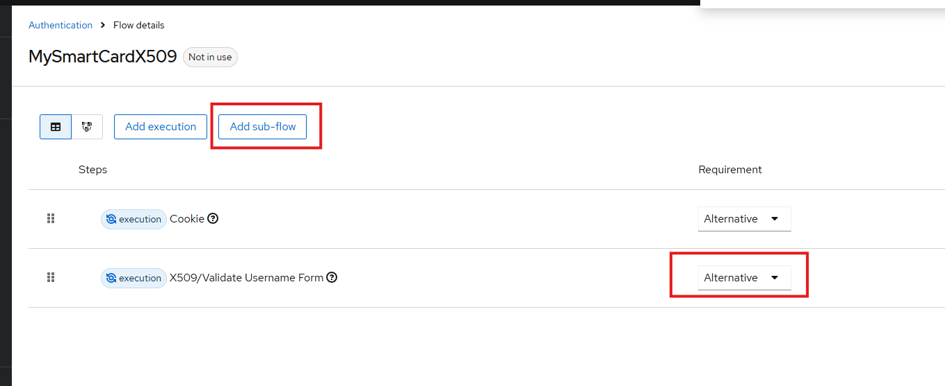

Provide the sub-flow name (Username Password Form), select Flow type as Generic then click Add:

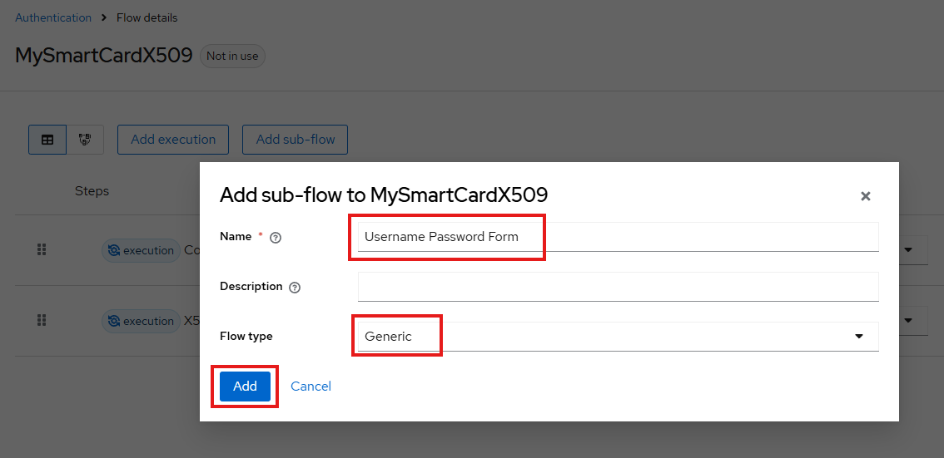

Select Alternative under Requirement column for the newly created sub-flow:

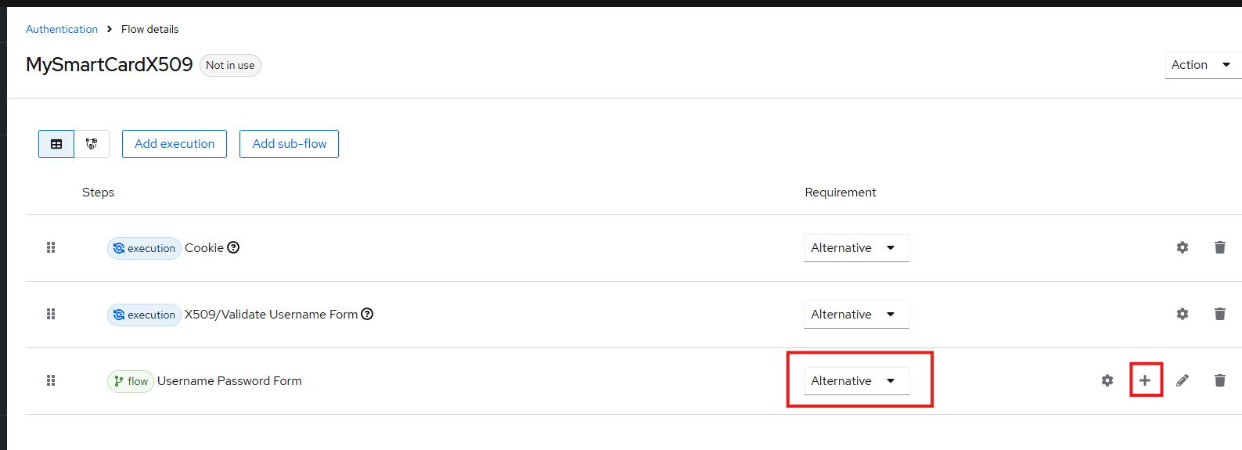

Click + then choose Add execution:

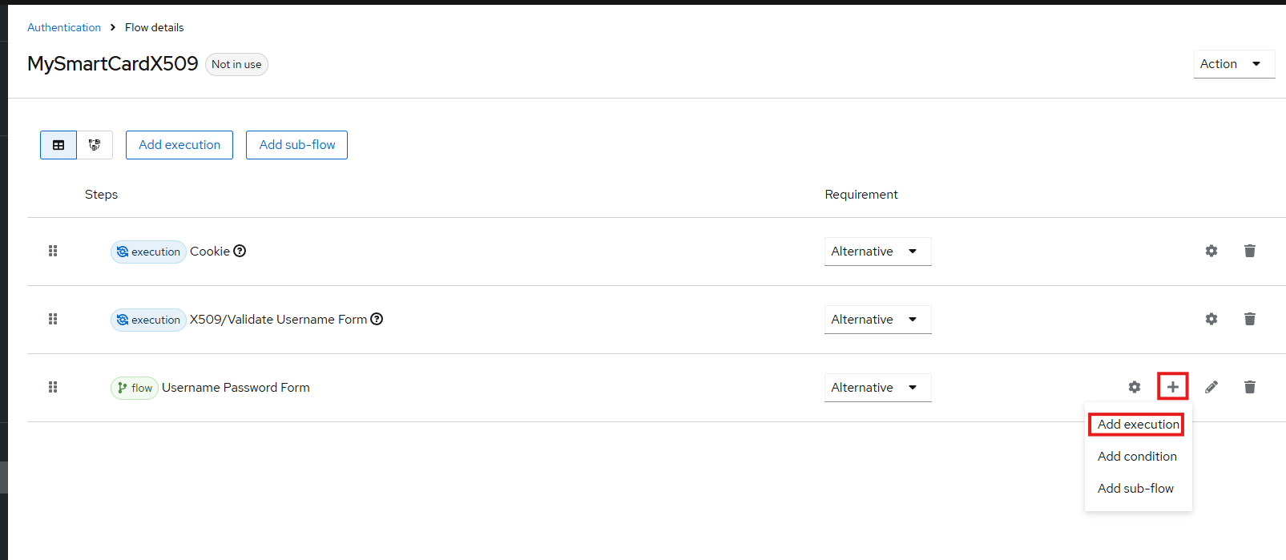

Find and choose Username Password Form then click Add:
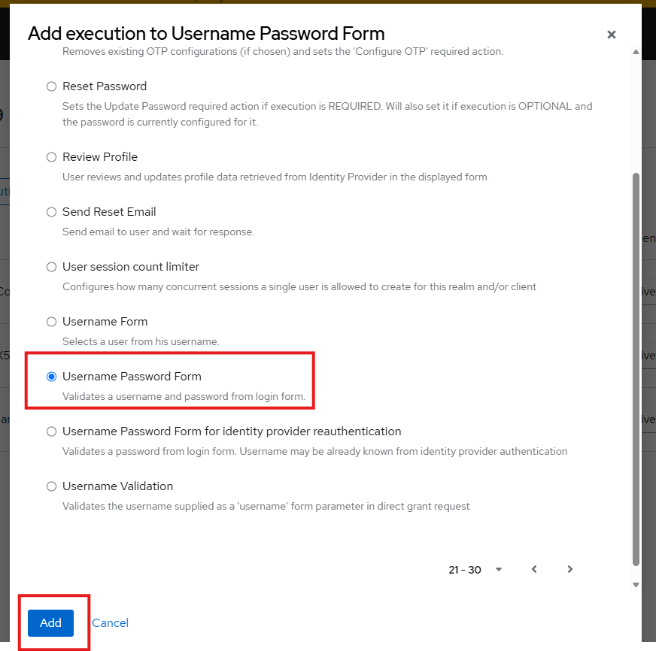

Make sure the Username Password Form is Required under Requirement column, then click the diagram button:

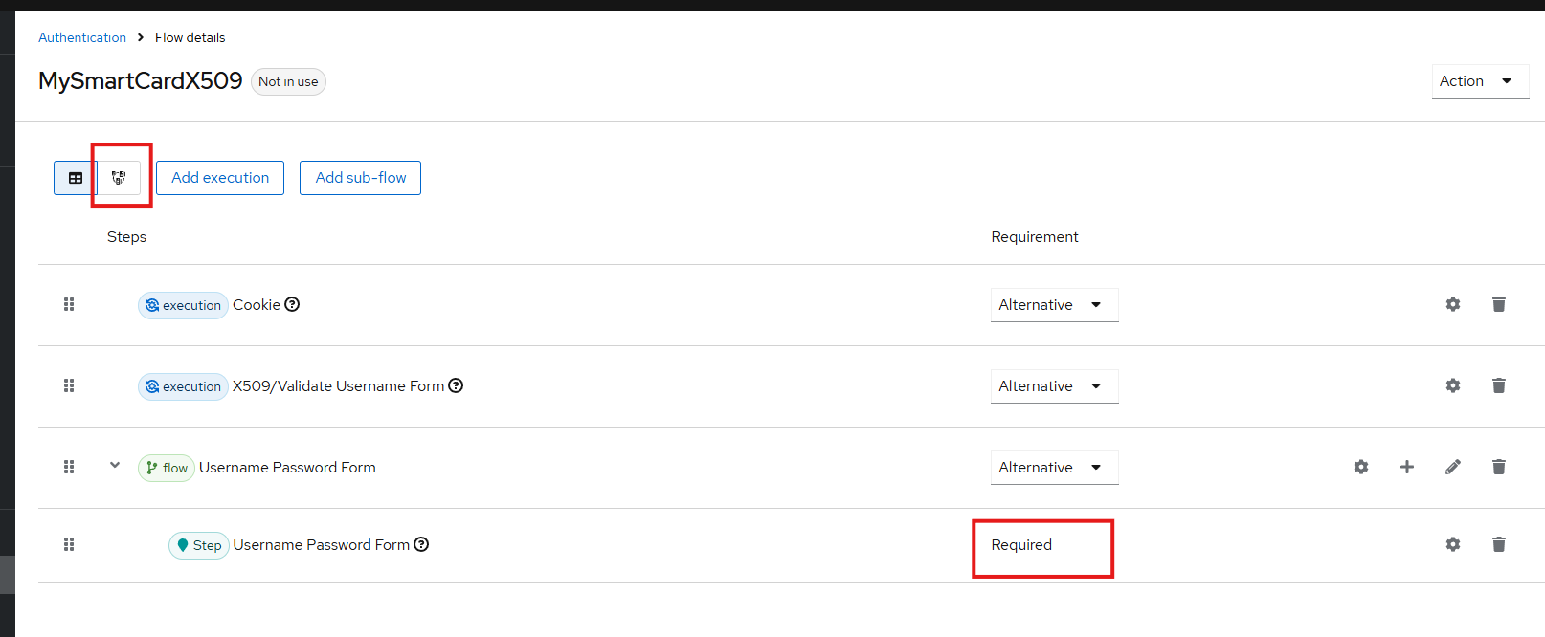

Verify the flow. The correct logic should be: If Cookie (single sign-on session) is not valid, it then attempts to do X.509 (smart card) authentication. If X.509 authentication is not successful or canceled, it attempts to do Username/Password authentication.
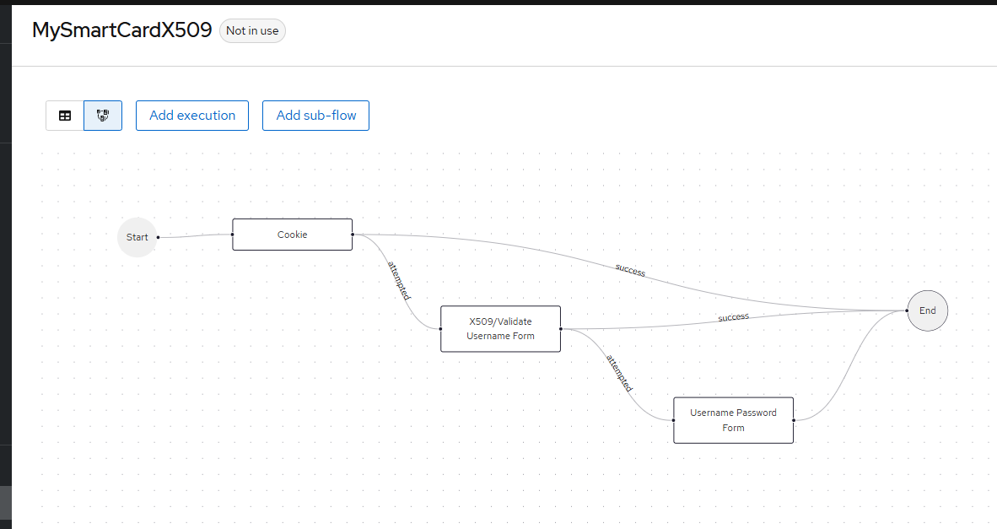

Then click Action and select Bind flow to make the flow as an active authentication flow:
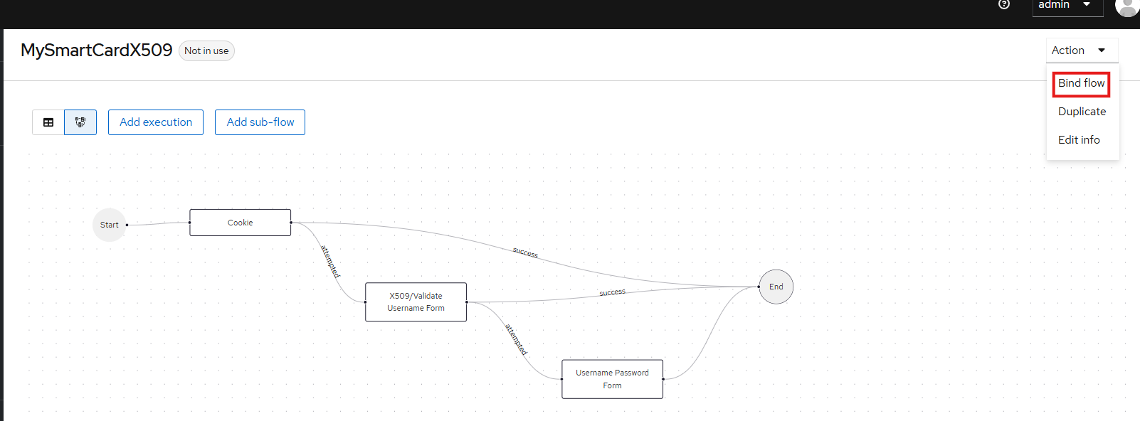

Choose Browser flow then Save:

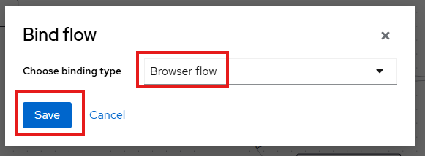

Click Authentication side link to verify the newly created flow is active:
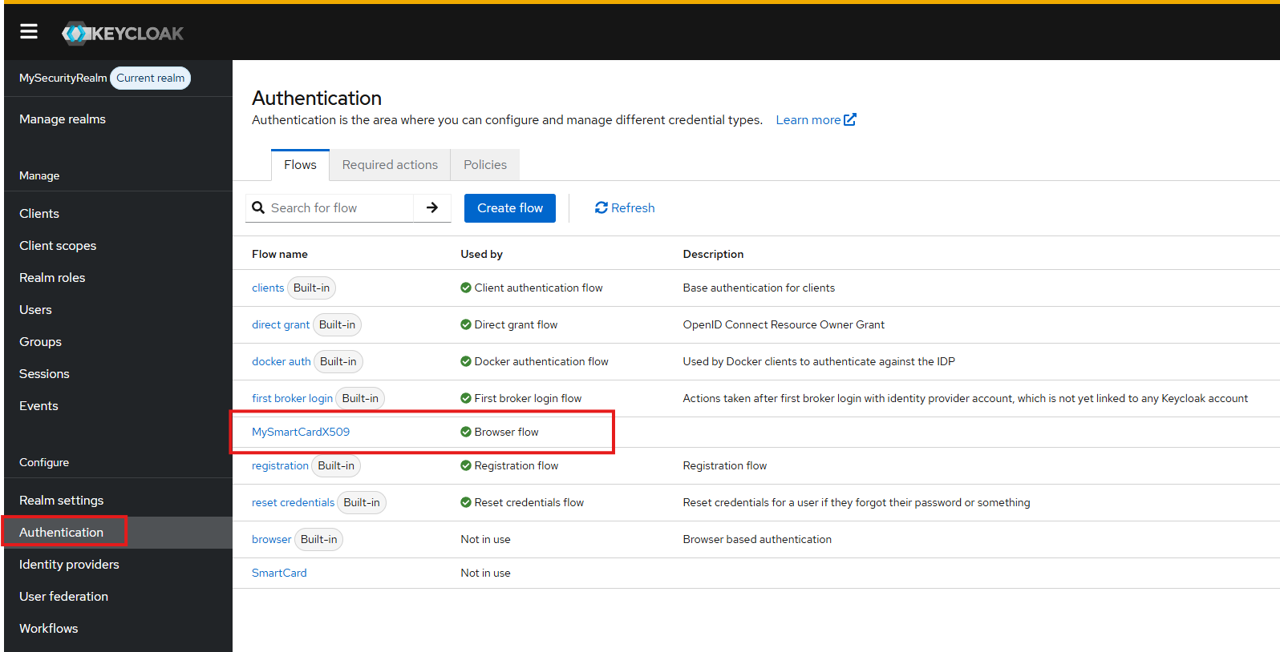

To Map Certificate Data to User Accounts:

In the newly created authentication flow then click the setting icon near the X509/Validate Username Form:
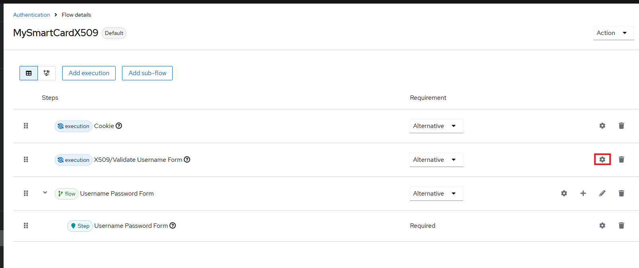

In the User Identity Source field, choose Subject’s Common Name:
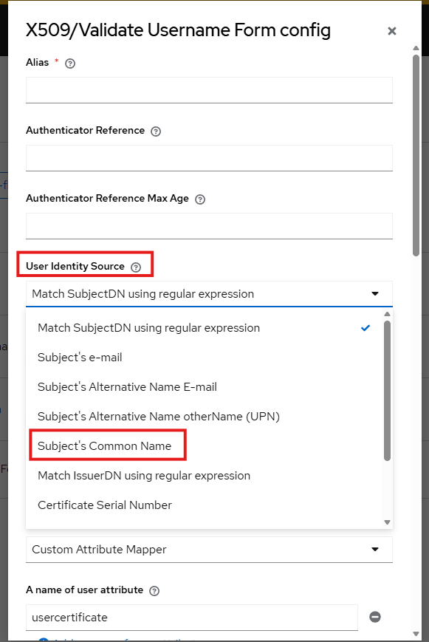
In User mapping method, choose Username or Email:
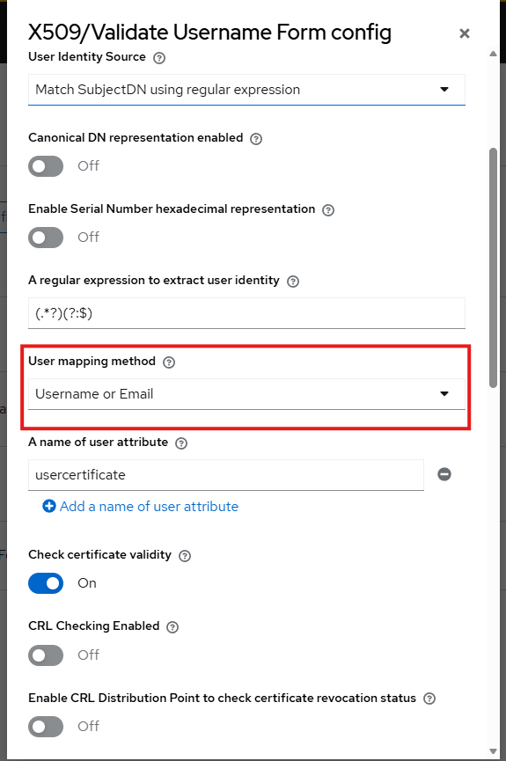
Provide the name (SmartCard Mapping) in Alias then click Save:
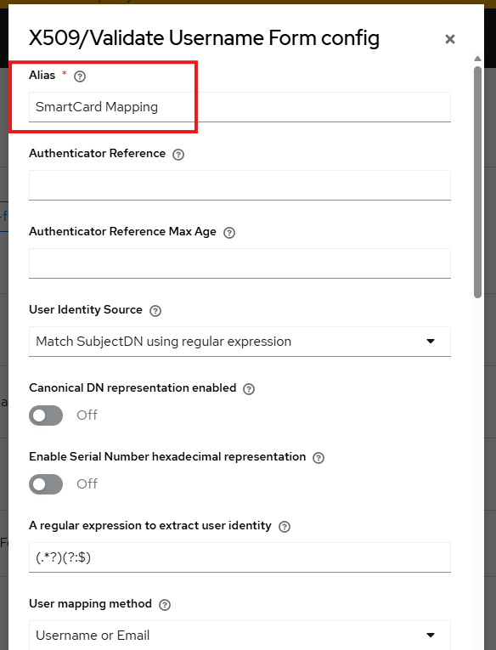

Make sure the CN value of the smart card matches the username of the security realm in Keycloak. This screen is the one when you are viewing the details of your smart card certificate:
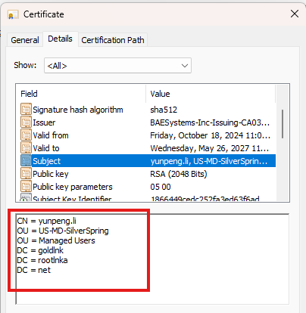
The username in Keycloak should match the CN value in your smart card certificate.
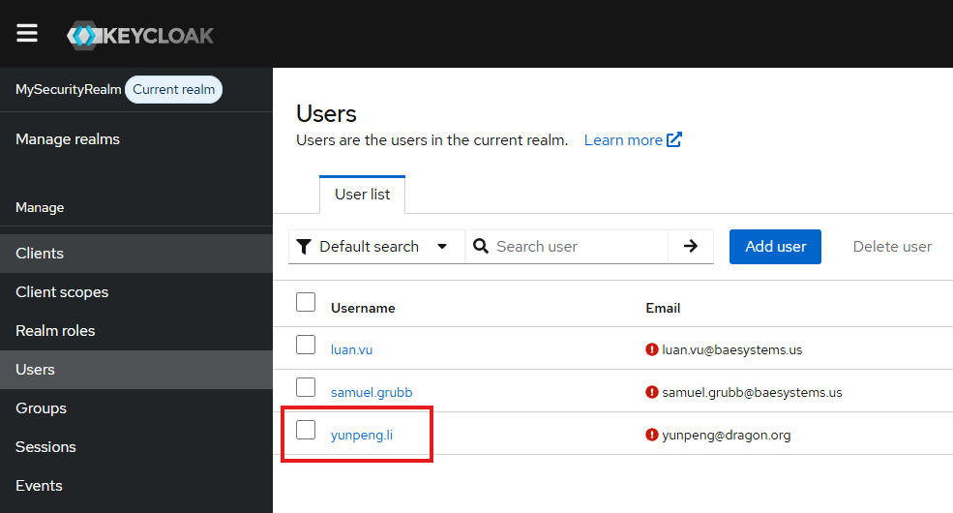

Restart Keycloak server, then try to access the Spring application that relies on the single sign-on service provided by the Keycloak server, it should redirect to an authentication page:

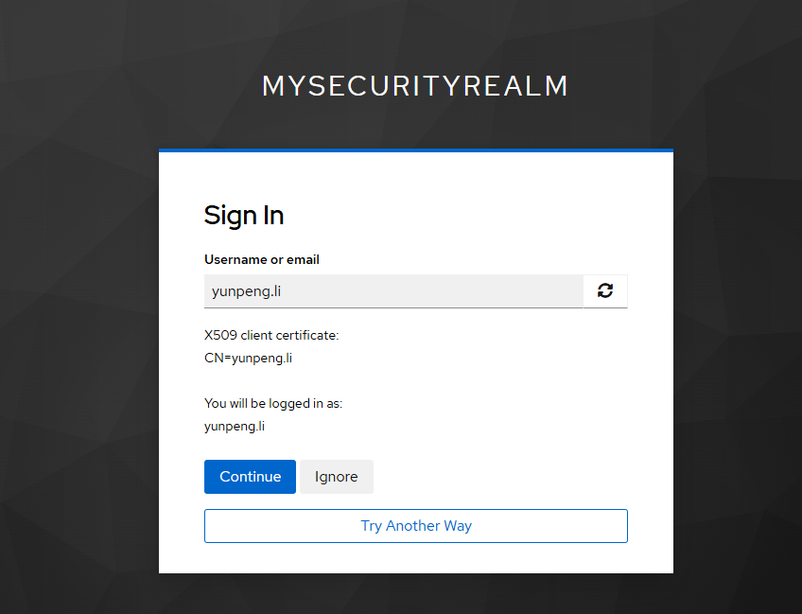

If click Continue, it will use X509 client certificate on smart card to login.

If click Ignore, it will use Username\Password form to login:
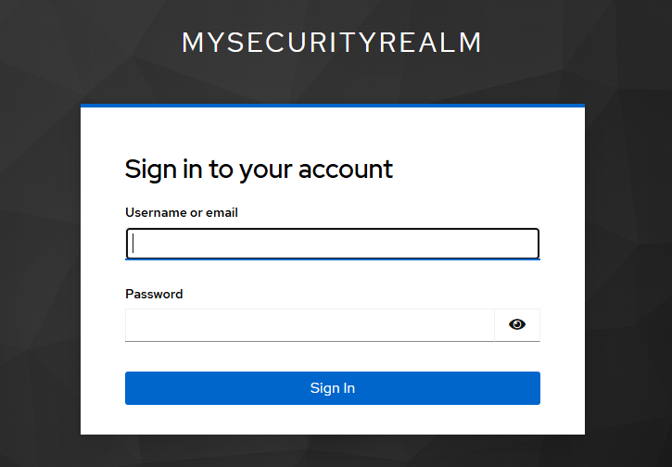

If click Try Another Way, it will provide 2 authentication approaches:
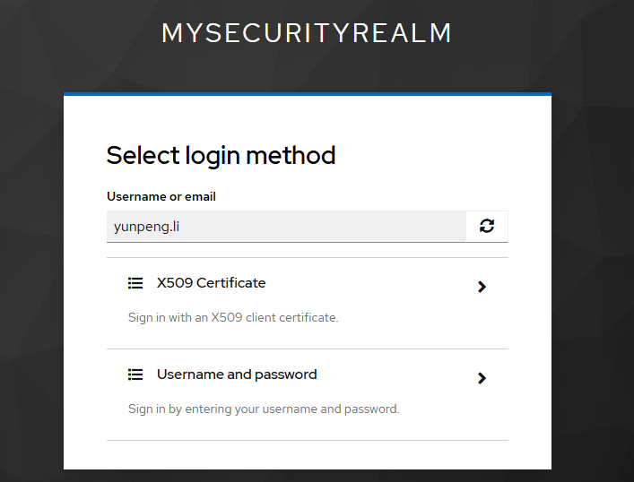
Note: Use Chrome’s Incognito or Edge’s InPrivate browser to make certificate prompt and avoid saving cookies during tests. Use the shortcut keys: Ctr + Shift + N when you are using Chrome or Edge.

Part IV: Demonstrate Single Sign On for two Spring Boot Applications

Start SpringBoot_SAML_App1 (run start_spring_app1.bat), then access https://your.spring.App1.IP:9091 in a browser. It will prompt for smart card certificate:
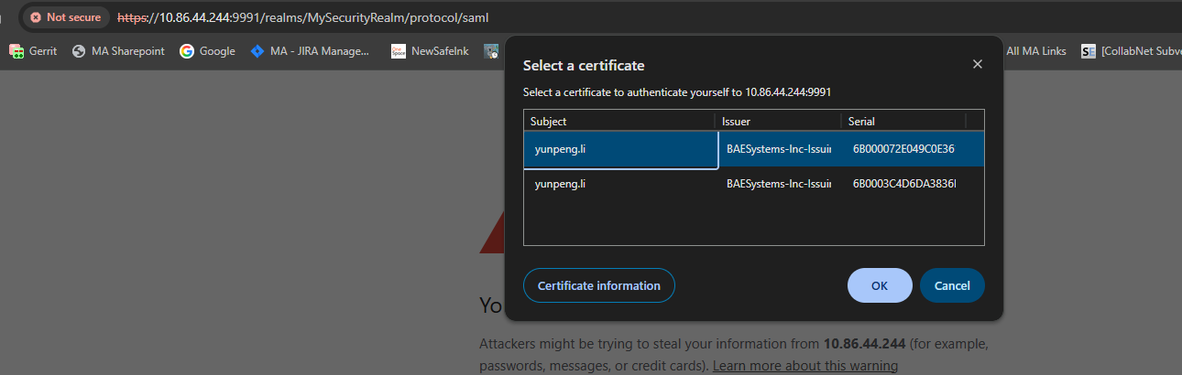

After selecting your certificate and then enter pin, it will direct to a Keycloak sign on page. Showing the Keycloak sign on page is only for demonstration purposes. You can configure authentication flow in Keycloak to not show such login page.
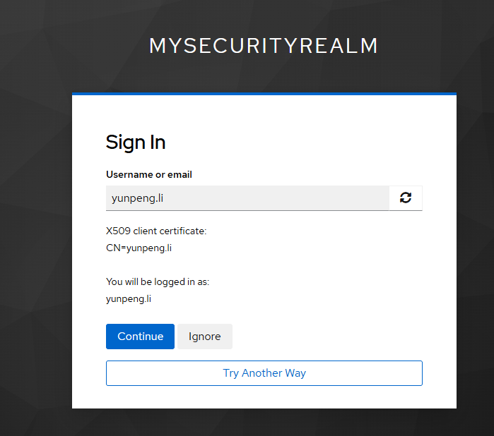
Click Continue, you should reach the home page of SpringBoot_SAML_App1:
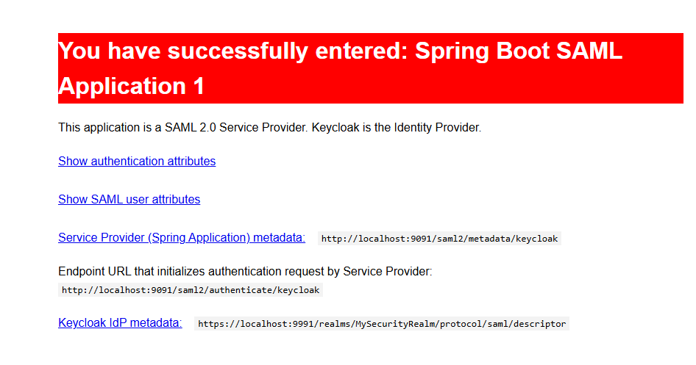
Start SpringBoot_SAML_App2 (run start_spring_app2.bat), then access https://your.spring.App2.IP:9092 in the same browser. It will not ask for login again, and you should reach the home page of SpringBoot_SAML_App2:
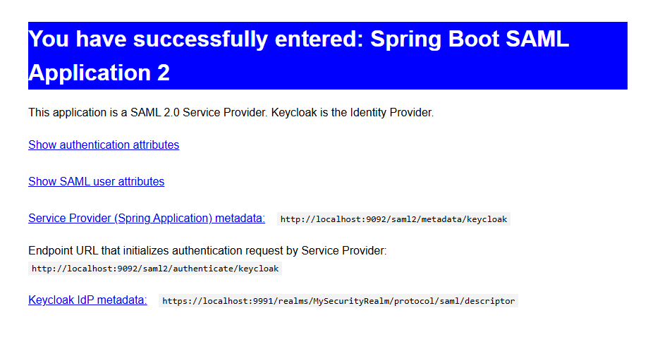
Log in Keycloak as admin and access Users under the Security Realm. It shows the user has both client sessions:
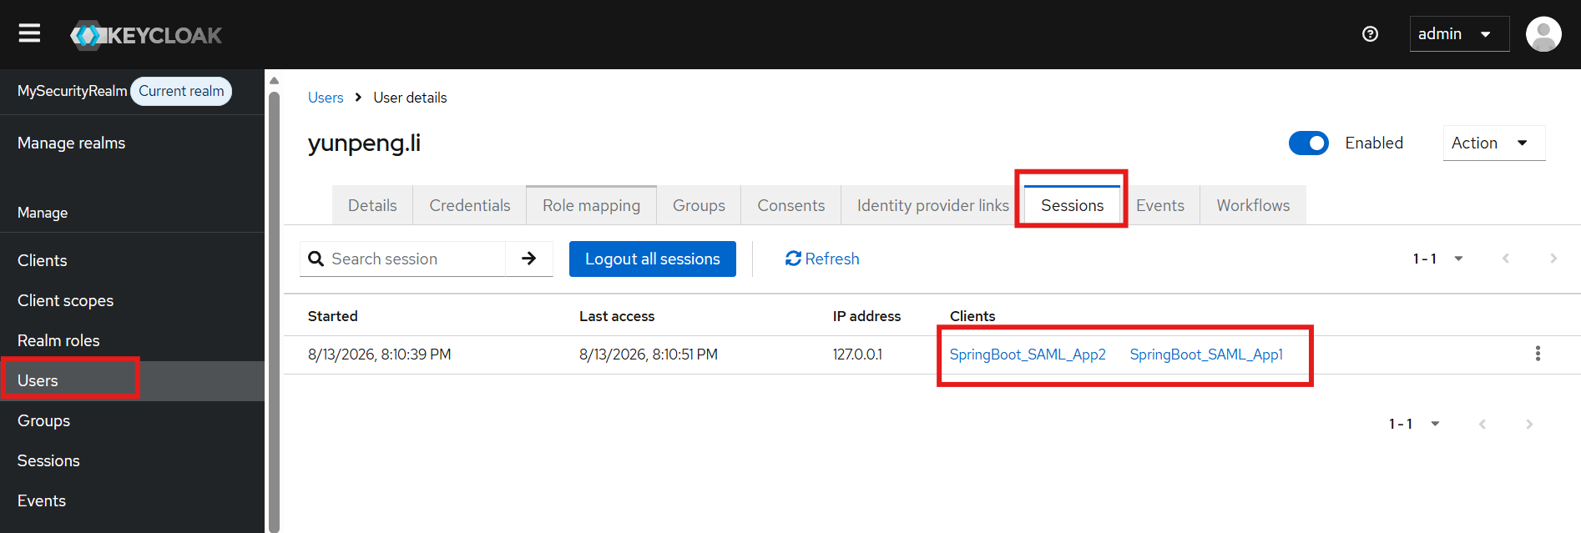

You can sign out the user from both client sessions:
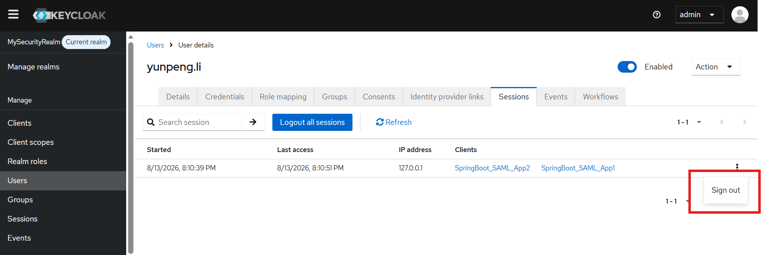

After user is signed out, accessing SpringBoot_SAML_App1 or SpringBoot_SAML_App2 requires login again.

Architecture Diagram:
